**McDonald US API**

1. **Get Current Menu**
   * **Method:** POST
   * **Endpoint:**  /mcdonalds/currentMenu
   * **Status:** 200 OK
   * **Response:**

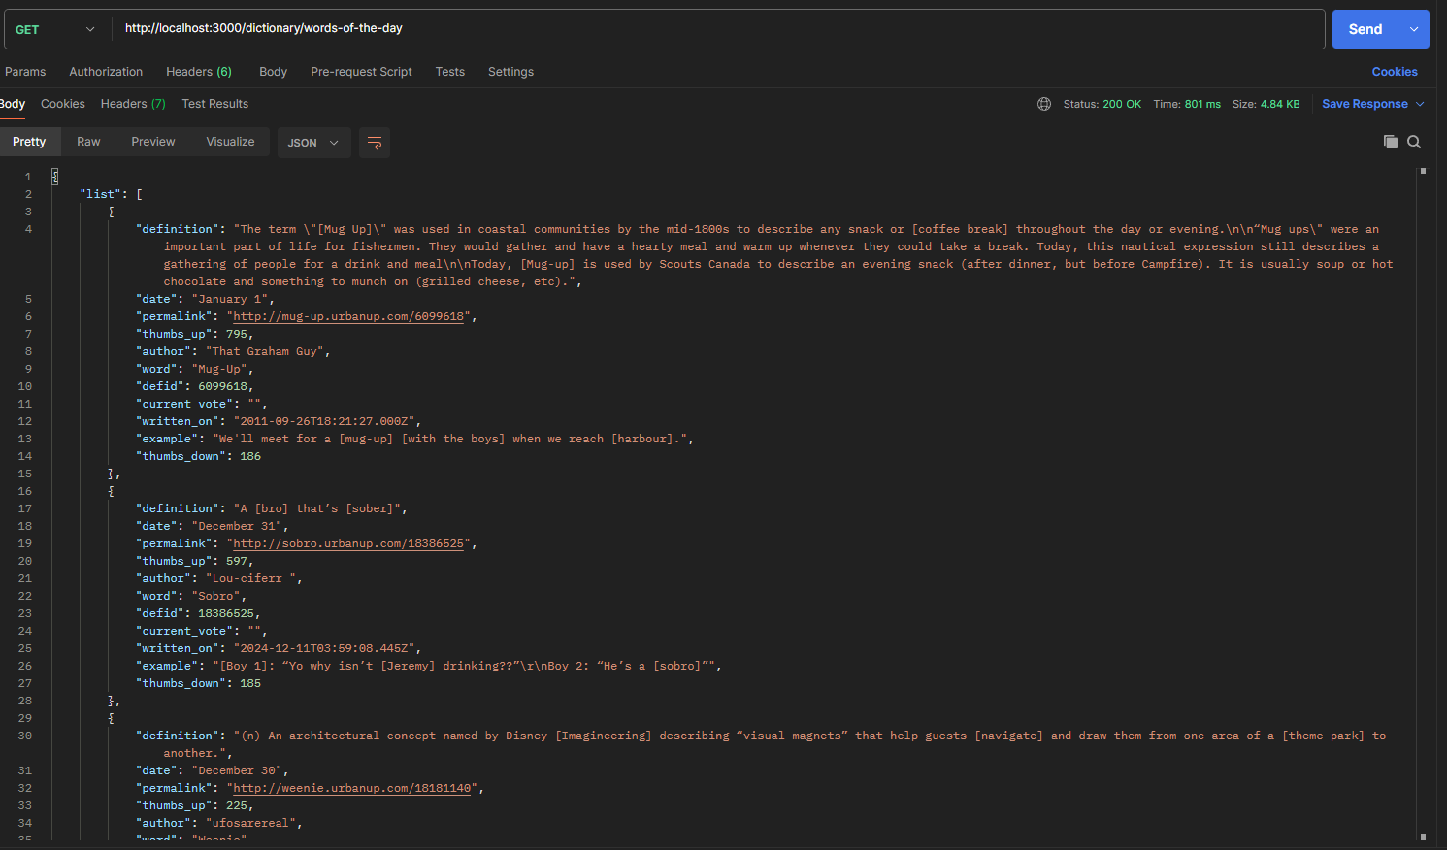

1. **Get Product By ID**
   * **Method:** GET
   * **Endpoint:**  /mcdonalds/product/203747
   * **Status:** 200 OK
   * **Response:**

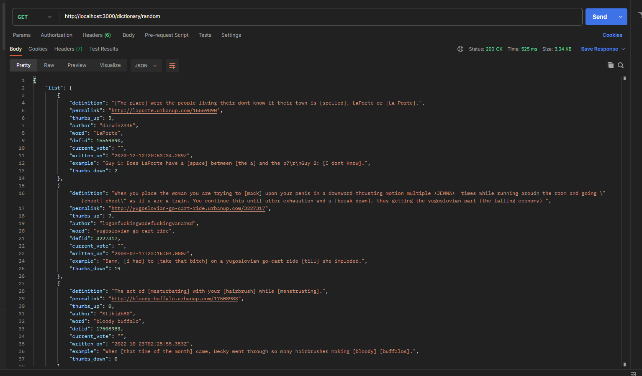

1. **Search**
   * **Method:** GET
   * **Endpoint:** /mcdonalds/search?search_term=Pepper&page=1&page_size=30
   * **Request Body:** 200 OK

